D424 – Software Engineering
Task 3
Capstone Proposal Project Name: |   Pantry Management Web Application
Student Name: | Kaitlyn Howell

Table of Contents
Contents
Table of Contents 2
Task 3 Design Document 3
Application Design and Testing 3
Class Design 3
UI Design 5
Unit Test Plan 10
Introduction 10
Purpose 10
Overview 10
Test Plan 11
Items 11
Features 11
Deliverables 12
Tasks 12
Needs 13
Pass/Fail Criteria 14
Specifications 15
Procedures 18
Results 18
Hosted Web Application 21
Hosted Web Application Link: 21
GitLab Repository & Branch History 21
GitLab Repository Link: 21
GitLab Branch History: 21
User Guide for Maintenance 21
Introduction 21
Pre-requisites 21
Application Setup 22
User Guide for Running the Application from User Perspective 24
Introduction 24
Installation and Using the Application 24
Login and Signup 24
Signup 24
Login 24
Pantry 25
Add Item 25
Edit Item 27
Delete Item 27
Search 27
Report 28

Task 3 Design Document

Application Design and Testing

Class Design
The class diagram for the Pantry Management Web Application (PMWA) illustrates the structure and relationships of the core components within the application. Built using ASP.NET Core MVC, the application adheres to object-oriented design principles, with a focus on the Single-Responsibility Principle (SRP) to ensure modularity and maintainability.
The application is designed to assist users in managing their kitchen inventory by tracking pantry items, categorizing them, and providing meaningful reports. The diagram highlights the relationships between key entities, including:
- Pantry: Represents the user’s single pantry and acts as a central repository for items.
- Item: Serves as a base class for all pantry items, containing shared attributes and methods.
- NonPerishableItem and PerishableItem: Specialized subclasses of Item that include unique attributes and behavior.
- ApplicationUser: Represents the user of the application and inherits from Entity Framework Core’s IdentityUser to utilize the powerful ASP.NET Core user authentication library, but provide custom user fields.
Additionally, the PantryController is included in the diagram to showcase its role in handling user interactions and coordinating between the User Interface (UI) and the core business logic. The PantryController provides the bulk of the methods for managing pantry items, searching, generating reports, and other pantry-specific actions.
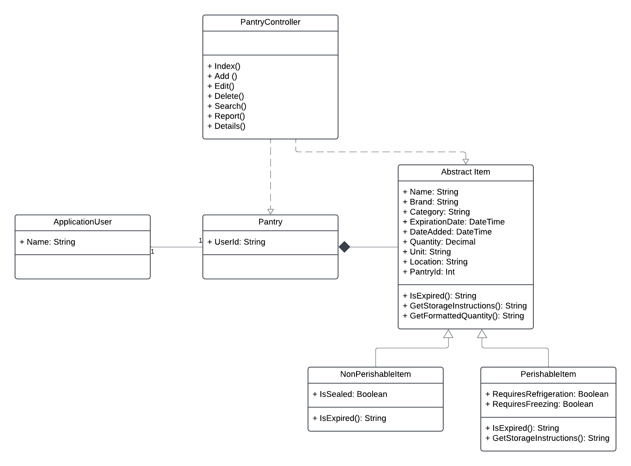

UI Design
The UI of the PMWA was designed to be intuitive and user-friendly. Key considerations when designing the user interface included consistency, accessibility, and functionality. This is shown through consistent design throughout pages, making interactive elements easy to understand, and communicating clearly to the end-user. The UI design begins with the homepage, which serves as the primary entry point to the application. It is crafted to visually communicate the application’s purpose through engaging visuals and purposeful text. The homepage also features prominently placed navigational elements, enabling users to easily access the application’s core functionalities.
The core features of the PMWA revolve around digitally cataloging and managing kitchen food items. Users can add, edit, and delete various types of items within their digital pantry using intuitive forms and actions. Each form is designed to guide the user with labeled fields and clear feedback. Interactive elements, such as buttons and dropdowns, are styled uniformly to ensure ease of use.
Additionally, the application includes dedicated pages for search and report generation features. The search page allows users to locate specific items within their pantry, while the reports page enables users to create detailed reports based on their pantry. Both pages display results in a clean, easy-to-read table for clarity.
The low-fidelity wireframes provided below showcase the placement of key elements for specific pages, providing a clear blueprint for implementation.
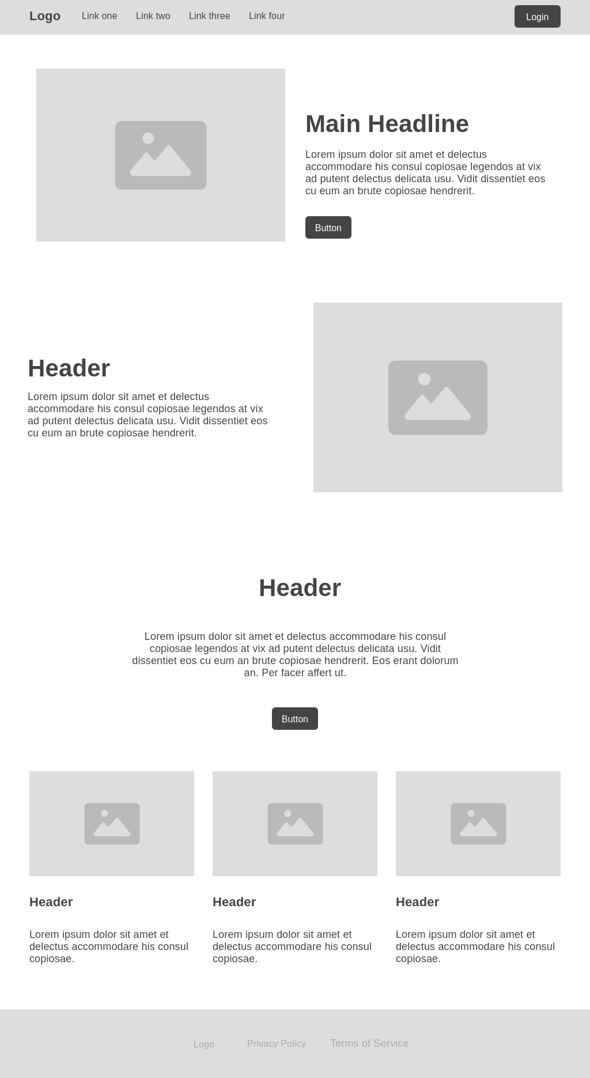
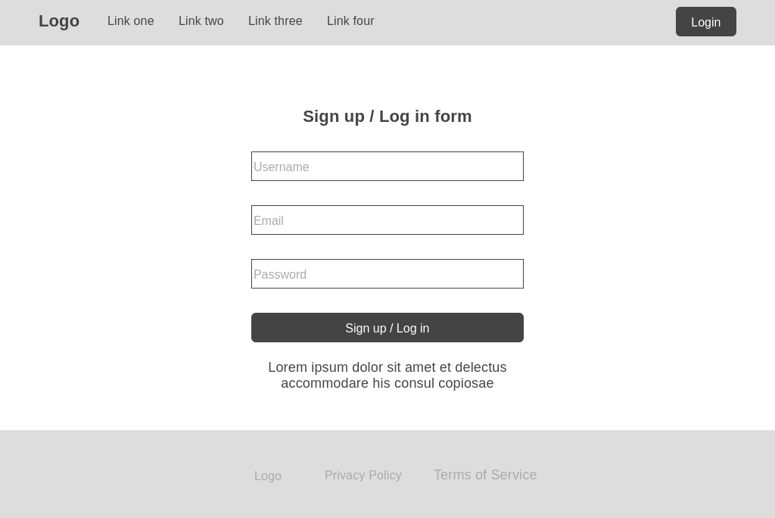

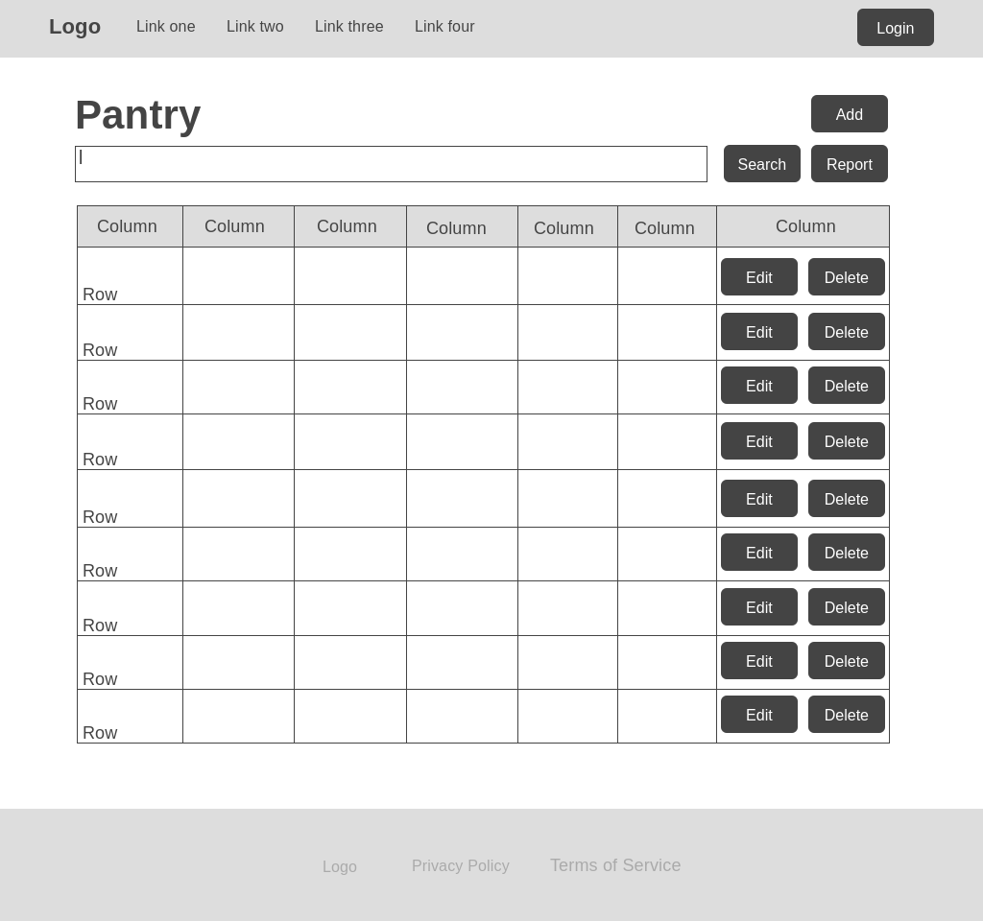
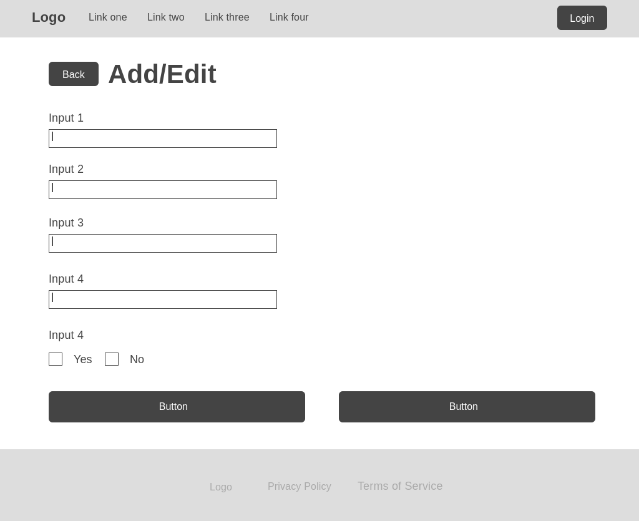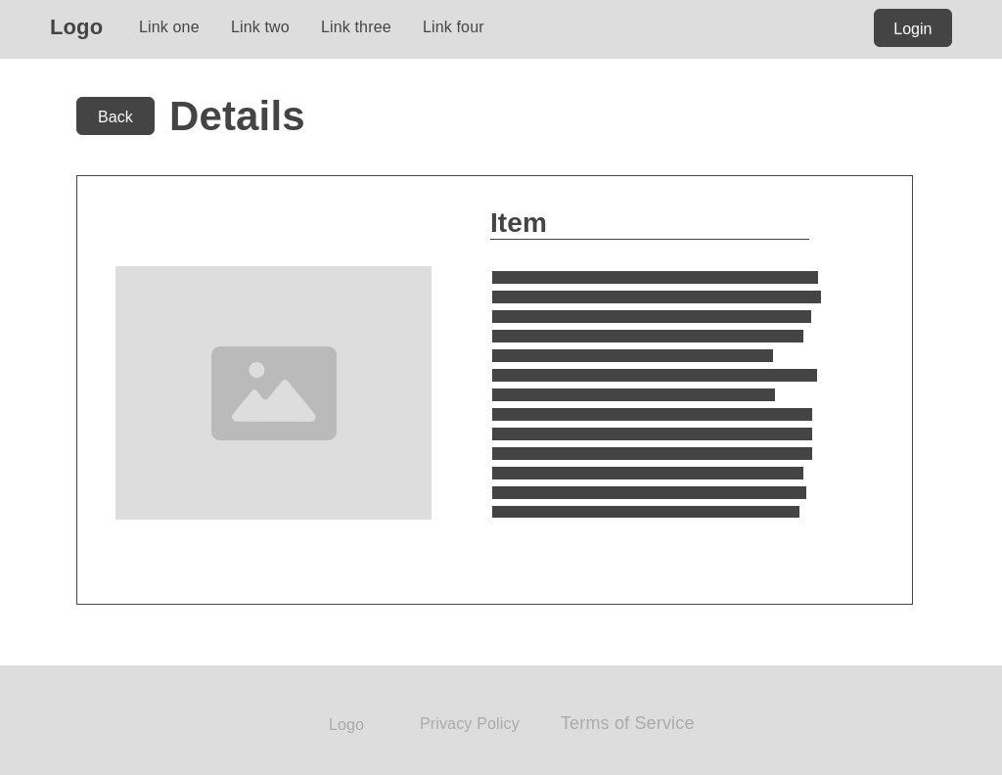
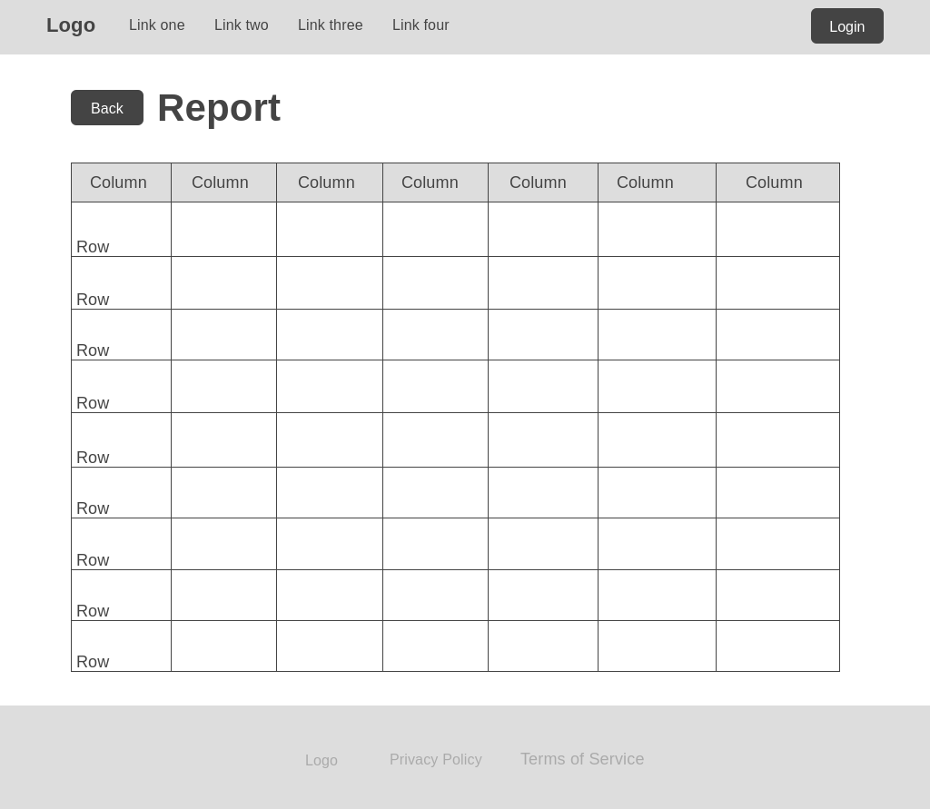
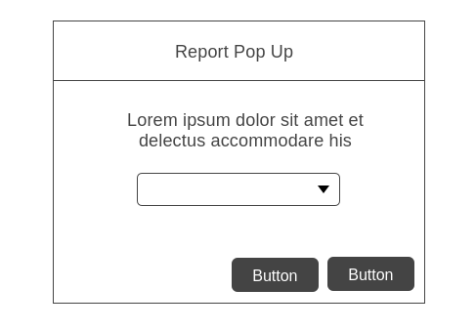

Unit Test Plan

Introduction

Purpose
The purpose of the unit testing process for the PMWA project was to ensure the functionality and reliability of key features in the application. Unit tests were conducted using the xUnit testing framework and the Moq library to simulate dependencies. These tests focused on verifying the behavior of critical methods, such as item search, report functionality, and item addition, under various conditions. The results of the unit tests confirmed that most methods performed as expected but allowed for the debugging and updating of those that did not.

Overview
The unit test plan for the PMWA was conducted to validate critical functions that ensure the accurate operation of the application and a positive user experience. The tests primarily focused on methods within the PantryController to assess how well the application handles critical user interactions including item management, search functionality, report generation, and accurate data retrieval. Each of these methods represents key aspects of the application’s functionality and its ability to manage data effectively.
Testing focused on isolating methods from external dependencies, such as the database or authentication system, using mocks. This approach ensures that the logic within the methods is examined thoroughly. While many of the methods used in these tests shared common patterns, like interacting with the database to retrieve and manipulate data, some were unique in their complexity and purpose.
- Search Functionality: The Search method was tested to verify its ability to filter pantry items based on user queries. Tests involved providing various search terms and verifying that the application returned accurate results. When any errors were encountered, adjustments were made to the code to handle these cases efficiently.
- Report Generation: The Report method was tested to validate that the application returned accurate item reports based on user choice.
- Item Management: Tests for item management involved verifying that both item types could be added to the database successfully and item-specific information could be retrieved.

Test Plan

Items
- Integrated Development Environment (IDE): Visual Studio was used to write, debug, and execute unit tests.
- Unit Testing Framework: xUnit provided the structure for creating and running the tests.
- Mocking Library: Moq was utilized to mock dependencies, such as the database context and authentication system.
- In-Memory Database: An in-memory instance of Entity Framework Core was used for tests requiring database interactions to simulate actual queries and operations.
- Application Codebase: Contains the functional methods that were the primary targets for testing.

Features
- Search Functionality: Test the ability to search for items based on user input.
- Reports: Test the generation of item reports based on user selection.
- Item Management and Details: Test the ability to add items to the database and subsequently retrieve accurate information on those items.

Deliverables
- Unit Test Scripts: Test scripts stored alongside the project codebase written using the testing framework, xUnit, and mocking framework, Moq.
- Test Result: A report summarizing the test results, including pass/fail status and any related error messages.

Tasks
- Set up the testing environment and install the necessary testing tools, xUnit and Moq, as well as EntityFrameworkCore.InMemory to configure the in-memory database for isolated testing.
- Create the test scripts for each feature defined in the Test Plan, including search functionality, report generation, and item management.
- Run the unit test scripts using the test runner and monitor for pass/fail outcomes.
- Review the test outcomes for failed tests and resolve any errors discovered during testing.
- Record test outcomes and identify areas for improvement. An example of the test outcomes:
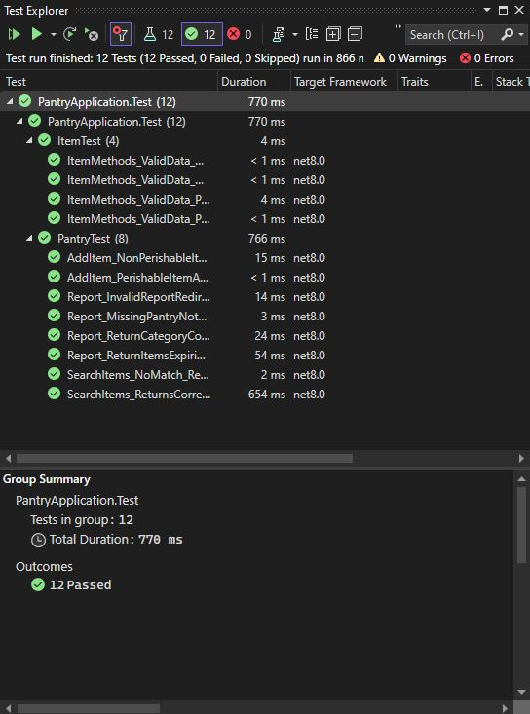

Needs
- Development Environment: Ensure Visual Studio 2022 (or later) is installed and configured with all necessary project dependencies, including SQL Server and in-memory providers.
- Software Dependencies: Ensure all required dependencies, including .NET Core SDK 8.0, ASP.NET Core Identity, and Entity Framework Core, are installed with compatible versions.
- Testing Libraries: Use xUnit as the testing framework, Moq for mocking dependencies, and EntityFrameworkCore.InMemory to simulate the database. These tools must be properly configured for the tests to run successfully.
- Application Codebase: To validate and execute tests, access to the source code, including the PantryController and related models, views, and database context, is required.

Pass/Fail Criteria
- Success Criteria:
  - The test passes if the output matches the expected result for the given input. For example:
    - Search Test: Returns accurate and relevant items matching the search term.
    - Report Test: Produces the correct report format with accurate data based on the selected report.
    - Item Test: Successfully adds a new item to the in-memory database and retrieves information about it accurately.
  - The application must showcase consistent behavior across all tests without throwing exceptions or producing unexpected functionality.
- Failure Protocol:
  - If a test fails, the test case is first reviewed for accuracy, and then the test is further investigated to identify the root cause of the failure. Further remediation steps include refactoring code to align with the expected behavior, and making sure all mocking and configurations are correctly implemented.
  - Document the specific failed test and the nature of the failure, the error message, the steps taken to address it, how to replicate it, and any other relevant information.

Specifications
Examples of unit test code for each functionality directly from the PMWA codebase are provided below.
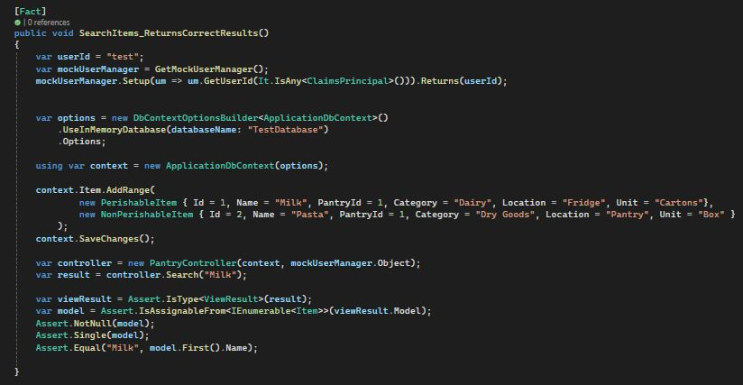
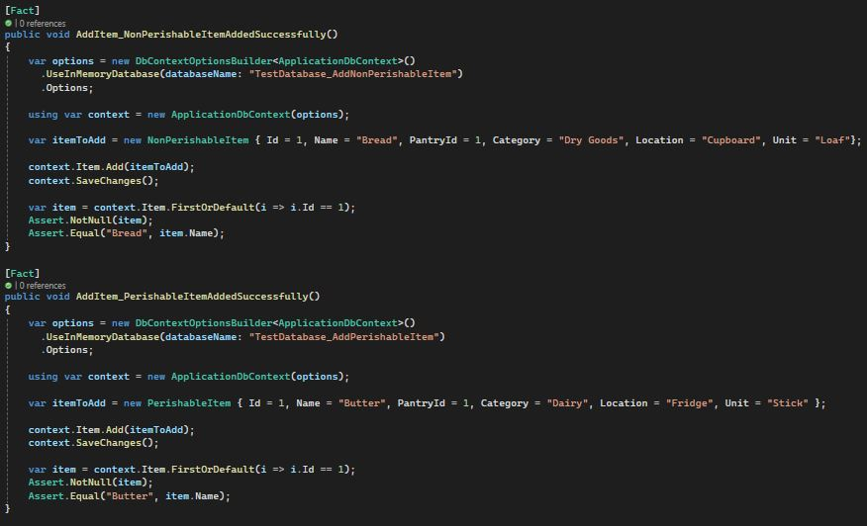
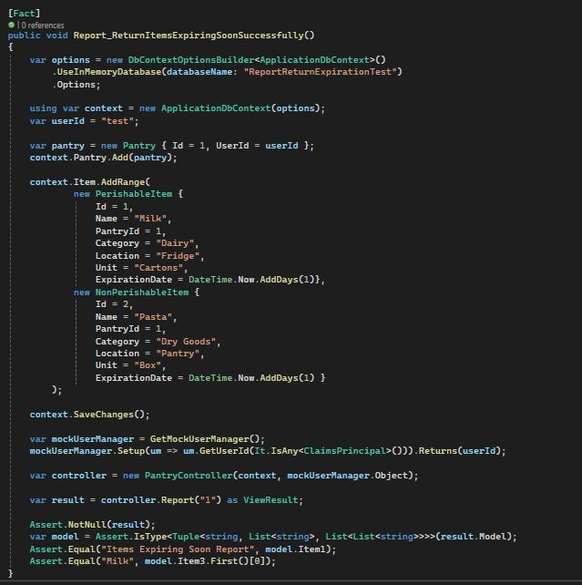
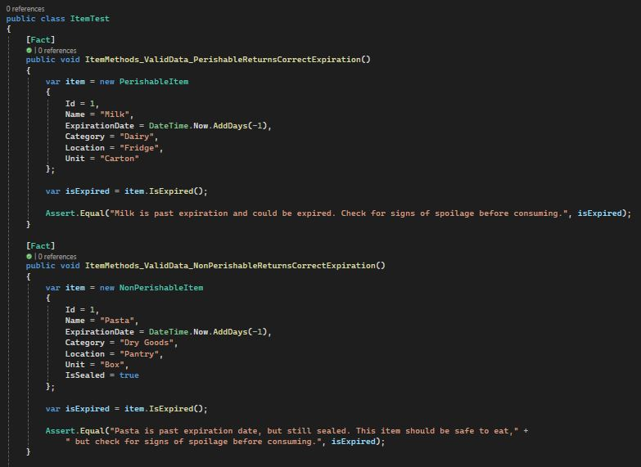

Procedures
- Setup Testing Environment: First, install any necessary libraries and tools such as xUnit, Moq, and InMemory. Then, configure the in-memory database for testing to simulate the application’s data storage without affecting the production database. Finally, ensure all dependencies, such as the application’s database context and user manager are properly mocked.
- Define Test Cases: Outline specific scenarios for each feature to be tested and document expected inputs and outputs for each test case.
- Write Unit Tests: Write test methods using xUnit to cover the previously defined scenarios.
- Execute Tests: Run each test individually using the xUnit test runner. Observe pass/fail outcomes and compare the actual results to the expected results. If a failure occurs, debug the application code or adjust the test case as necessary. Repeat with all tests.
- Analyze results: Document pass/fail outcomes for each test, including detailed notes for any failures and their resolutions.

Results
The testing process ______, validating the functionality of critical application features. Below is a summary of the results for each major feature:
- Search Functionality:
  - Test Scenario: Searching for items in the pantry by name.
  - Result: Passed. All relevant items matching the search term were retrieved successfully. Tests for edge cases, such as a non-existent item, also passed, accurately returning no results.
- Report Generation:
  - Test Scenario: Generating reports for expiring items and category counts.
  - Result: Passed. Reports were returned in the correct format, with appropriate data. Invalid report types and missing pantry cases were handled correctly and redirected accordingly.
- Item Management:
  - Test Scenario: Adding items to the pantry and retrieving details about added items.
  - Result: Passed. Both types of items were successfully added to the database with the correct information. Item-specific details, such as storage instructions, were retrieved successfully from added items of both types.
The final results confirmed the application’s functionality met the intended requirements, and all tests passed successfully. Below is a screenshot from the xUnit test runner, showcasing the test execution results.


Hosted Web Application

Hosted Web Application Link:
https://pantrynote.azurewebsites.net

GitLab Repository & Branch History

GitLab Repository Link:
https://gitlab.com/wgu-gitlab-environment/student-repos/khow331/d424-software-engineering-capstone/-/tree/working?ref_type=heads

GitLab Branch History:
[!!!!update when you have all commits done!!]

User Guide for Maintenance

Introduction
This guide provides instructions for setting up and running the application to ensure it remains operational and can be maintained effectively.

Pre-requisites
- Create a Microsoft Azure account (https://azure.microsoft.com/en-us/get-started/azure-portal) and set up a SQL Server and a SQL Database.
  - Copy the newly created database’s connection string (this can be accessed by selecting "Connection strings” under database settings).
    - 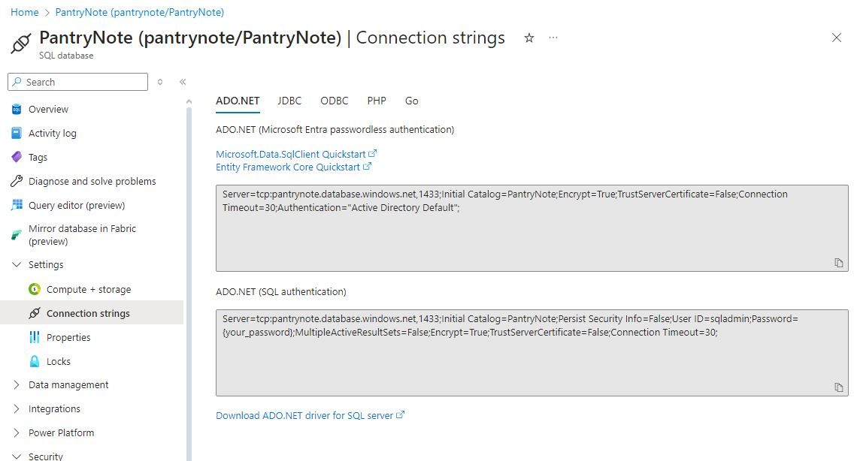
- Download Visual Studio 2022 (or later) with the following workloads:
  - ASP.NET and web development
  - .NET desktop development

Application Setup
- Clone the repository
  - Open a terminal or Git client.
  - Run the following command to clone the repository:
    - git clone https://gitlab.com/wgu-gitlab-environment/student-repos/khow331/d424-software-engineering-capstone.git
  - Navigate to the project directory:
    - cd pantryapplication
- Configure the Database:
  - Open the appsettings.json file in the project directory.
  - Update the connection string with your SQL Server instance details.
    - Example:
    - 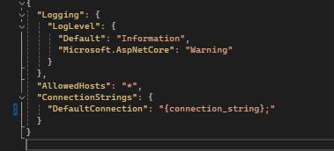
  - Run the following command to run database migrations:
    - dotnet ef database update
- Restore Dependencies:
  - Open the solution in Visual Studio
  - Restore NuGet packages by clicking Tools > NuGet Package Manager > Manage NuGet Packages for Solution, then click Restore.
- Build and Run the Application:
  - Set the project as the startup project in Visual Studio.
  - Press F5 or click Start to build and run the application.
- Deployment/Deploying Updates:
  - Build and publish the application using Visual Studio’s built-in publishing by right-clicking the application directory, selecting “Publish”, and following the prompts. This can also be achieved by navigating to the Azure portal (https://portal.azure.com), selecting “App Services”, and clicking “Create Web App.”
By following these steps, the application can be set up, maintained, and updated efficiently.

User Guide for Running the Application from User Perspective

Introduction
This user guide provides detailed instructions to guide users through the signup and login process, and how to use all the features of the application. It is designed to ensure that users can seamlessly navigate through the application.

Installation and Using the Application
To begin using the application, first navigate to the application URL: https://pantrynote.azurewebsites.net.

Login and Signup

Signup
- To register for a new account and begin using the application’s functions, click the “Register” button in the top right corner of the application.
  - 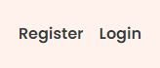
- Enter your name and email and create a unique password. Your password must be at least 6 characters long and include an upper-case letter and a unique character.
- If successful, you will be redirected to the homepage, where you will see a unique greeting and a new navigation link titled “My Pantry” at the top of the page.

Login
- If you already have an account, click the “Login” button in the top right corner of the application.
- Enter your email address and password and press the “Log in” button.
- If successful, you will be redirected to the homepage, where you will see a unique greeting and the “My Pantry” navigation link at the top of the page.

Pantry

Add Item
- To begin using your pantry, click the “My Panty” link in the top left corner of the application. NOTE: This will only be available to logged in users.
- If this is your first time adding an item, you will be met with a screen informing you that your pantry is empty. Click the “Add Item” button located in the middle of the screen.
  - Ex.
  - 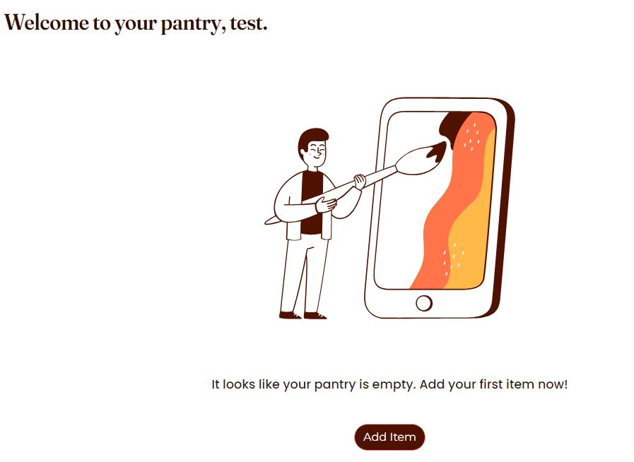
  - If you already have items in your pantry, the “Add Item” button will be located on the right-hand side of your screen, above your items.
  - Ex.
  - 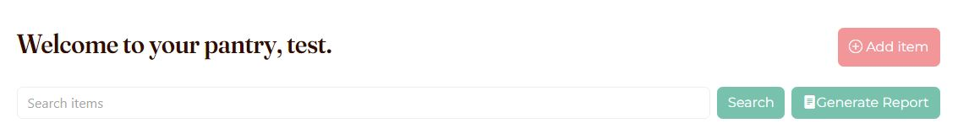
- If your item is a perishable item, click “Perishable.” If your item is a non-perishable item, click “Non-Perishable.”
- Fill out the form using information about the item you are adding. Brand and expiration date are optional fields.
  - 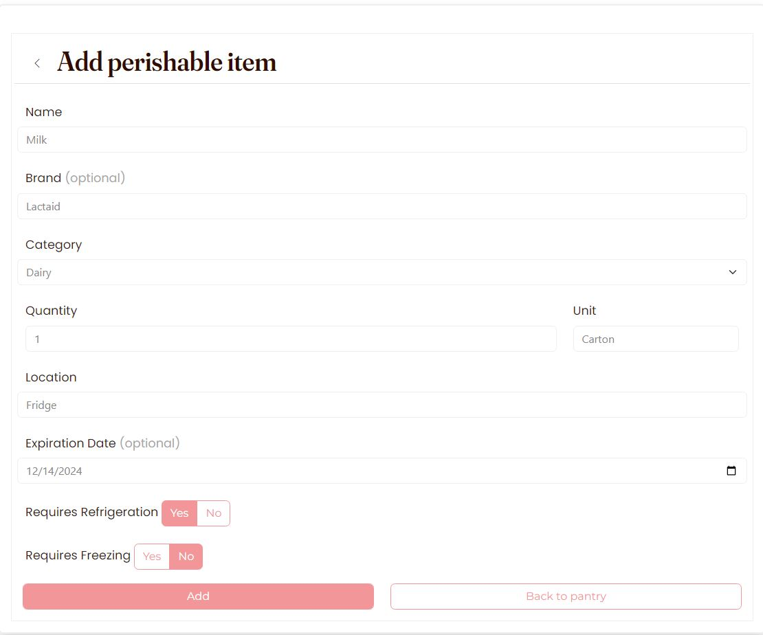
- Click “Add” at the bottom of the form to add the item. Otherwise, click “Back to pantry” to return to your pantry.

Edit Item
- To edit an existing item in your pantry, find the table row that corresponds to the item you want to edit, and click the button with the pencil icon on the far right.
  - 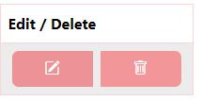
- Edit the item details to your liking and click “Update” to submit the changes or “Back to pantry” to cancel the changes and return to your pantry.

Delete Item
- To delete an existing item from your pantry, find the table row that corresponds to the item you want to delete, and click the button with the garbage can icon on the far right.
- When prompted, click “Yes, delete” to delete the item, or “No, cancel” to close the modal and cancel the deletion.
  - 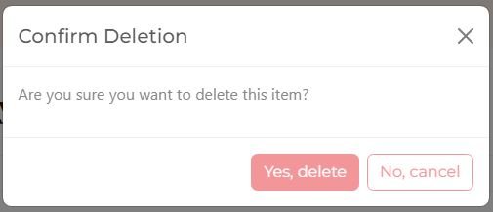

Search
- To search your pantry items by name, click on the search bar at the top of your pantry, enter your search query, and press the “Search” button to the right.
  - 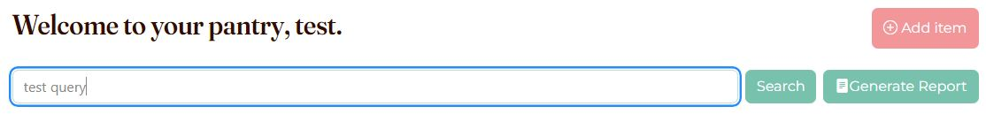
- You will be directed to a page containing your search results or informing you that no results were found.
  - 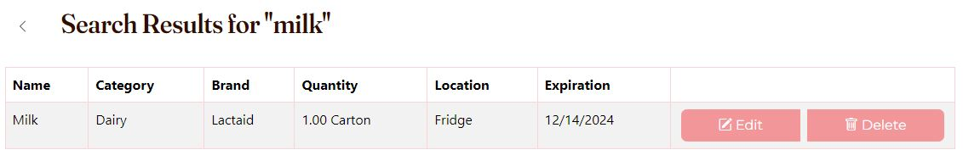
- To return to your pantry, click the “<” button to the left of the search result header or click on the “My Pantry” button on the navigation bar.

Report
- To generate a report, click on the “Generate Report” button located to the right of the search button.
  - 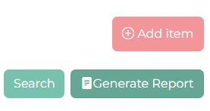
- To select a report type, click on the drop-down menu and choose an option. Once selected, click the “Generate” button to generate the report or “Close” to close the modal and return to your pantry.
  - Items Expiring Soon Report
    - This report will give you a quick look at the items in your pantry that are expiring within 30 days.
  - Category Count Report
    - This report will give you insight into how many items of different categories you have within your pantry and the last time you added them.
- You will be directed to a page containing your report data or informing you that you do not have items to support the report. (Ex. If none of the items in your pantry expire within 30 days, a report will not be generated due to lack of data.)
  - 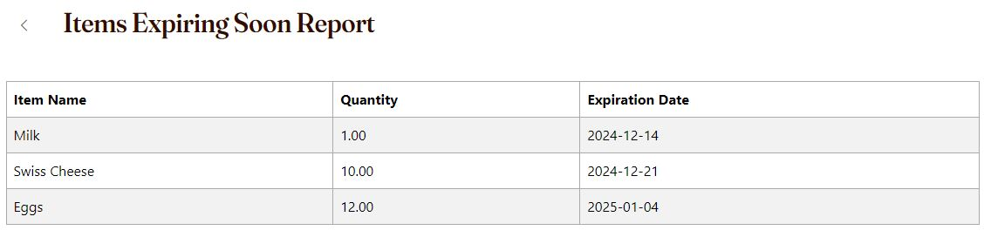
- To return to your pantry, click the “<” button to the left of the report header or click on the “My Pantry” button on the navigation bar.

